SEMINAR | 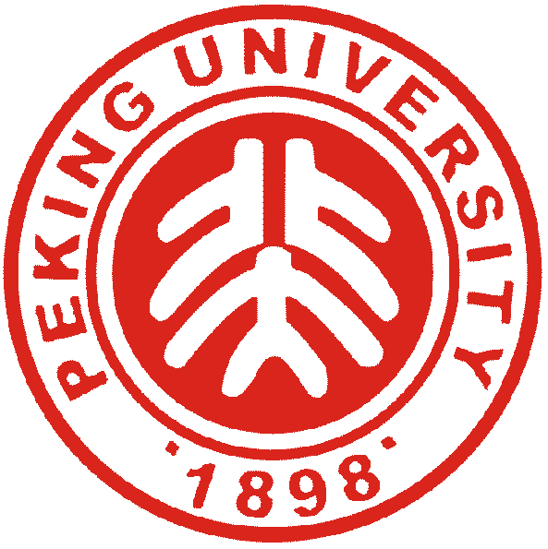 | SERIES
北京大学工学院 |  | 力学与工程科学系
Multidimensional immunoengineering approaches to enhance cancer immunotherapy
报告人: Li Tang
École polytechnique fédérale de Lausanne (EPFL)
时 间：4月22日（周二）15:30-16:30
地 点：工学院1号楼210会议室
主持人：熊春阳
内容简介：
Our immune system interacts with many diseases in a multidimensional manner involving substantial biological, chemical, and physical exchanges. Manipulating the disease-immunity interactions may afford novel immunotherapies to better treat diseases such as cancer, an emerging field termed ‘immunoengineering’. My lab aims to develop novel strategies to engineer the multidimensional immunity-disease interactions to create safe and effective therapies against cancer. We leverage the power of metabolic and cellular bioengineering, synthetic chemistry and material engineering, and mechanical engineering to achieve controllable modulation of immune responses. In this talk, I will first discuss our discovery of a new type of immune checkpoint with mechanical basis that is distinct from most known immune checkpoints of biochemical traits. We further developed novel interventions to overcome the mechanical immune checkpoint for enhanced cancer immunotherapy. Next, I will talk about our recent discovery of IL-10 and IL-4, type 2 immune function-related cytokines, as metabolic reprogramming agents that reinvigorate the terminally exhausted CD8+ tumor infiltrating lymphocytes. This strategy has been extended to developing metabolically armored CAR-T cells with IL-10 secretion to counter exhaustion-associated dysfunction in the tumor microenvironment for enhanced anticancer immunity. This new CAR-T cell therapy, i.e. IL-10-secreting CAR-T, has shown promise in several on-going IIT clinical trials (NCT06393335, NCT05715606, NCT05747157, NCT06120166, NCT06277011) in the treatment of refractory/relapsed CD19+ B cell leukemia and lymphoma.
报告人简介：
Li Tang received his B.S. in Chemistry from Peking University, China, in 2007, and Ph.D. in Materials Science and Engineering from University of Illinois at Urbana-Champaign, USA, in 2012, under the supervision of Prof. Jianjun Cheng. He was a CRI Irvington Postdoctoral Fellow in the laboratory of Prof. Darrell Irvine at Massachusetts Institute of Technology during 2013-2016. He joined the faculty of Institute of Bioengineering, and Institute of Materials Science & Engineering, at École polytechnique fédérale de Lausanne (EPFL), Switzerland, as a Tenure-Track Assistant Professor in 2016, and promoted to Associate Professor with tenure in 2022. He is also the Vice Dean for Innovation, and Director of Innovate4Life program at School of Life Sciences, EPFL. His research focuses on developing multidimensional immunoengineering approaches for enhanced cancer immunotherapies. Dr. Tang is the recipient of Friedrich Miescher Award (2025) from Life Sciences Switzerland (LS2), Leenaards Prize for Translational Medical Research (2025), Biomaterials Science Lectureship (2025), CAB Mid-Career Investigator Award (2024), Biomaterials Award for Young Investigators (2024), Cancer Research Institute CLIP Award (2021), Anna Fuller Award (2021 and 2022), European Research Council (ERC) Starting Grant Award (2018), and named in the MIT Technology Review’s "Top 35 Innovators under Age 35" list of China region (2020).

欢迎广大师生光临！

